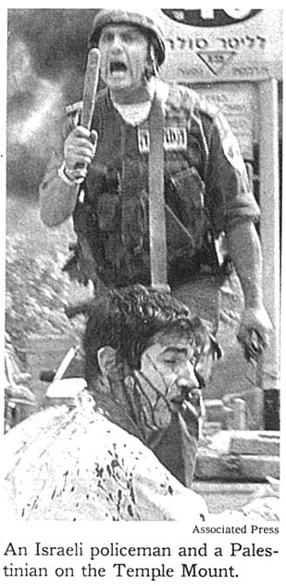

**New York Times, September 30, 2000**

Dr. Aaron Grossman of Chicago sent the following letter to the Times:

Regarding your picture on page A5 of the Israeli soldier and the Palestinian on the Temple Mount -- that Palestinian is actually my son, Tuvia Grossman, a Jewish student from Chicago. He, and two of his friends, were pulled from their taxicab while traveling in Jerusalem, by a mob of Palestinian Arabs, and were severely beaten and stabbed.

That picture could not have been taken on the Temple Mount because there are no gas stations on the Temple Mount and certainly none with Hebrew lettering, like the one clearly seen behind the Israeli soldier attempting to protect my son from the mob.

*Source:* [*http://www.honestreporting.com/articles/reports/The_Photo_that_Started_it_All.asp*](http://www.honestreporting.com/articles/reports/The_Photo_that_Started_it_All.asp)

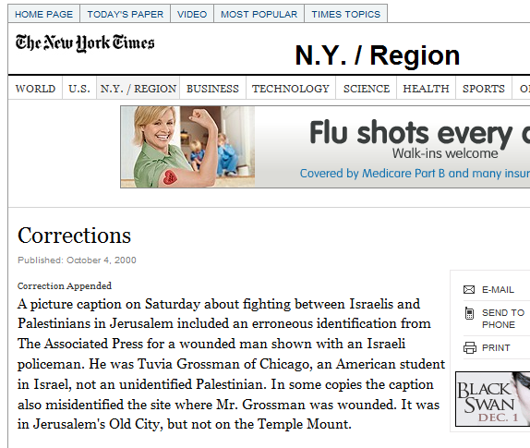

[*http://www.nytimes.com/2000/10/07/nyregion/c-corrections-542970.html*](http://www.nytimes.com/2000/10/07/nyregion/c-corrections-542970.html)

*For more information, see* [*http://www.fraudfactor.com/ffmediafraud9001.html*](http://www.fraudfactor.com/ffmediafraud9001.html)

*Ten years later, a dramatic reunion:* [*http://www.youtube.com/watch?v=B_6m06YoSaI*](http://www.youtube.com/watch?v=B_6m06YoSaI)